Design Principles – Logan Pierce

CIT230

Proximity

Shutterfly

<https://www.shutterfly.com/>

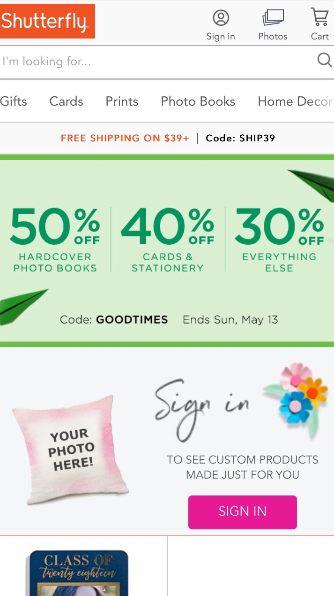

Shutterfly sells a wide variety of products. They’re all grouped close together to make it easier for the customer to see all their options.

Alignment

Elf on the Shelf

<https://www.elfontheshelf.com/>

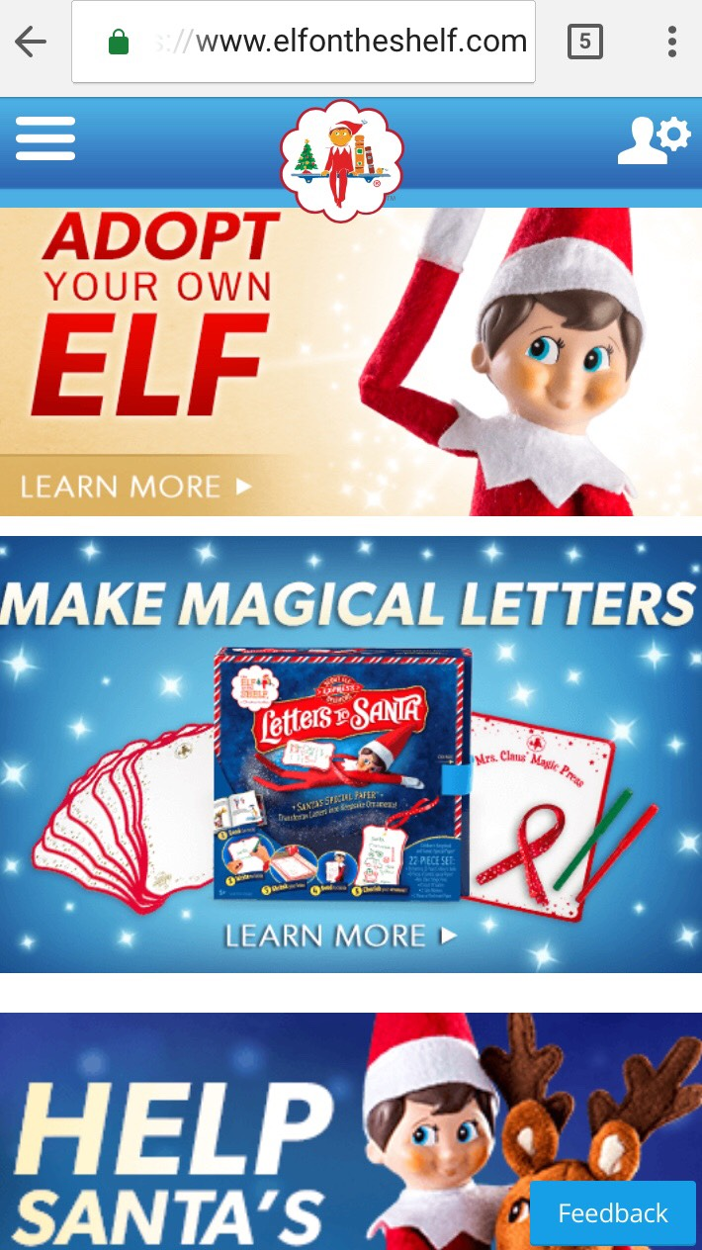

As one might expect, the Elf on the Shelf mobile site excels at alignment. Nothing is positioned haphazardly and all the visual elements share a connection.

Repetition

Evernote

<https://evernote.com/>

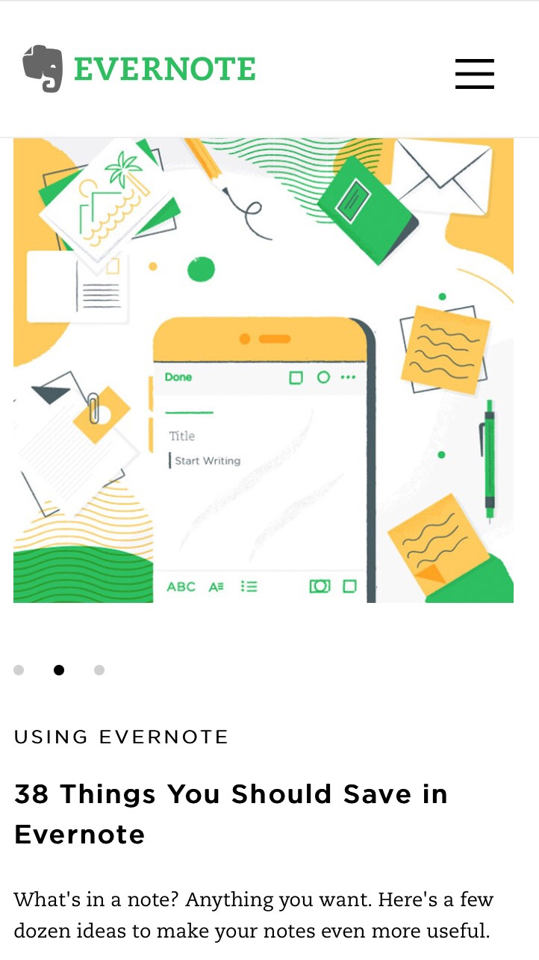

Evernote’s mobile site layout is clean and uncluttered. It repeatedly uses green and yellow colors over a white background.

Contrast

Huffington Post

[www.huffingtonpost.com](http://www.huffingtonpost.com)



The bold, white text of the headline stands out against the cover photo of the story. By shortening the to “HuffPost,” and condensing the headlines of stories, the site aims to be mobile-friendly.

Typography

Typeform

<https://www.typeform.com>



Typeform touts topnotch text while eschewing excessive videos and visuals so as to better serve those using mobile devices.